IDEATION PHASE - DOCUMENT 3:

EMPATHY MAP CANVAS
Date | 06 November 2025
Team ID | 7DDB99C3AFBFD678BC14B32342A420F8
Project name | Medical Inventory Management
Maximum Marks | 4 Marks

Title: Brainstorming for “Medical Inventory Management”

1.Objectives :
To create a platform that connects restaurants, households, and food providers with NGOs and people in need.

- To reduce food wastage by redistributing surplus edible food safely.

- To provide real-time updates on available food donations and pickup requests.

- To ensure smooth coordination between donors, volunteers, and beneficiaries.

- To promote social responsibility and awareness about hunger reduction.

2. Stakeholders Identified :
Stakeholder |  | Role / Interest
Food Donors (Hotels, Homes, Events) |  | Donate excess safe-to-eat food
NGOs / Charities  Volunteers / Delivery Personnel Pick up and transport food |  | Collect and distribute food to needy people
End Beneficiaries (Needy People) | Receive food support
Health & Safety Authorities  System Administrator / App Owner Manage platform, users & operations | Ensure food safety regulations
System Administrator / App Owner | Manage platform, users & operations

3.Emapthy map canvas layout :

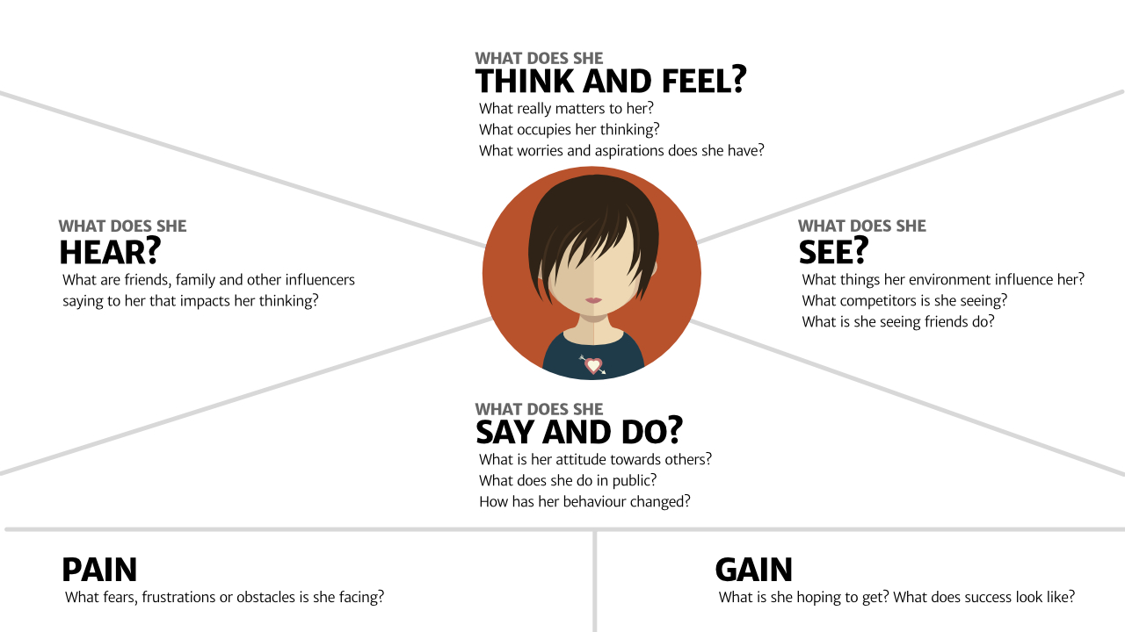

Says:
“We have leftover food daily, but we don’t know how to distribute it safely.”

Thinks:
“If I donate this food easily, it could help many people. But I need a reliable system.”

Does:
Packs leftover food but usually ends up throwing it away.

Feels:
Guilty about wasting food and wants a simple solution.

4. Empathy Map Analysis :
Section Explanation :
Says They are open to donating food but need a simple and quick process.
Thinks Concerns about hygiene, reliability, and trust in recipients.
Does Currently wastes food due to lack of connection with NGOs.
Feels Regret for wastage but motivated to help society if guided properly.

5. Insights Derived :

- Donors need a fast and convenient way to notify when food is available.

- Beneficiaries and NGOs require location-based updates.

- Volunteers want a clear pickup schedule and directions.

- Trust and hygiene assurance is a key concern for all stakeholders.

6. Design Implications for Medical Inventory:

- The app should have real-time food availability alerts.

- Include GPS-based pickup and delivery routing.

- Provide food safety guidelines and rating/trust system.

- Simple one-click request and donation interface.

- Transparent communication between donor, volunteer, and NGO.

7. Empathy Map Canvas Summary :

The empathy map highlights that stakeholders feel responsible and willing to help, but lack a structured and simple platform for donation. A clear, user-friendly app with location and time-based coordination will reduce food waste and improve access to food for those in need.

